Coins Poem

Penny, penny easily spent,
1¢
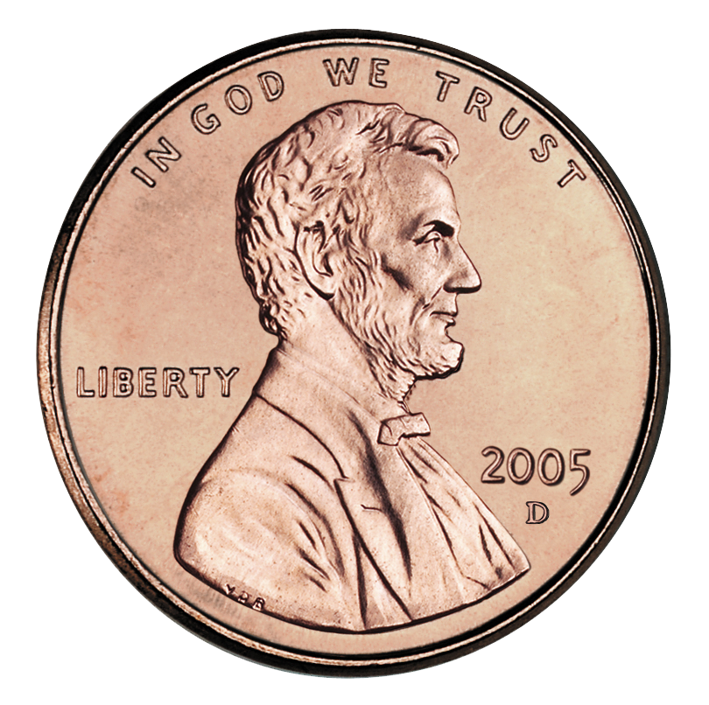
copper brown
and worth one cent!
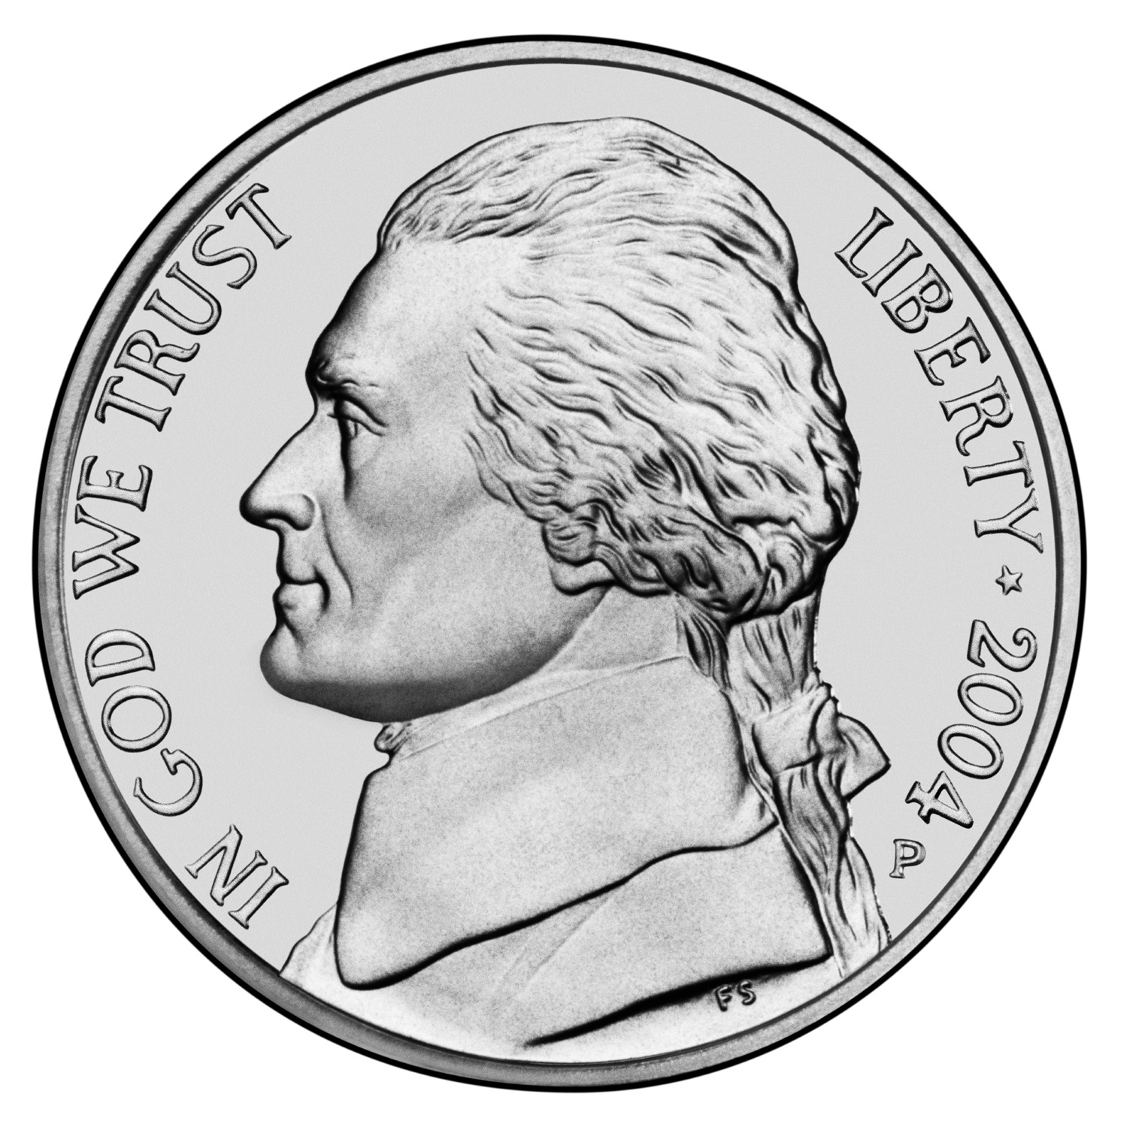
Nickel, nickel thick and fat,
5¢
worth five cents
and I know that!

Dime, dime little and thin,
10¢
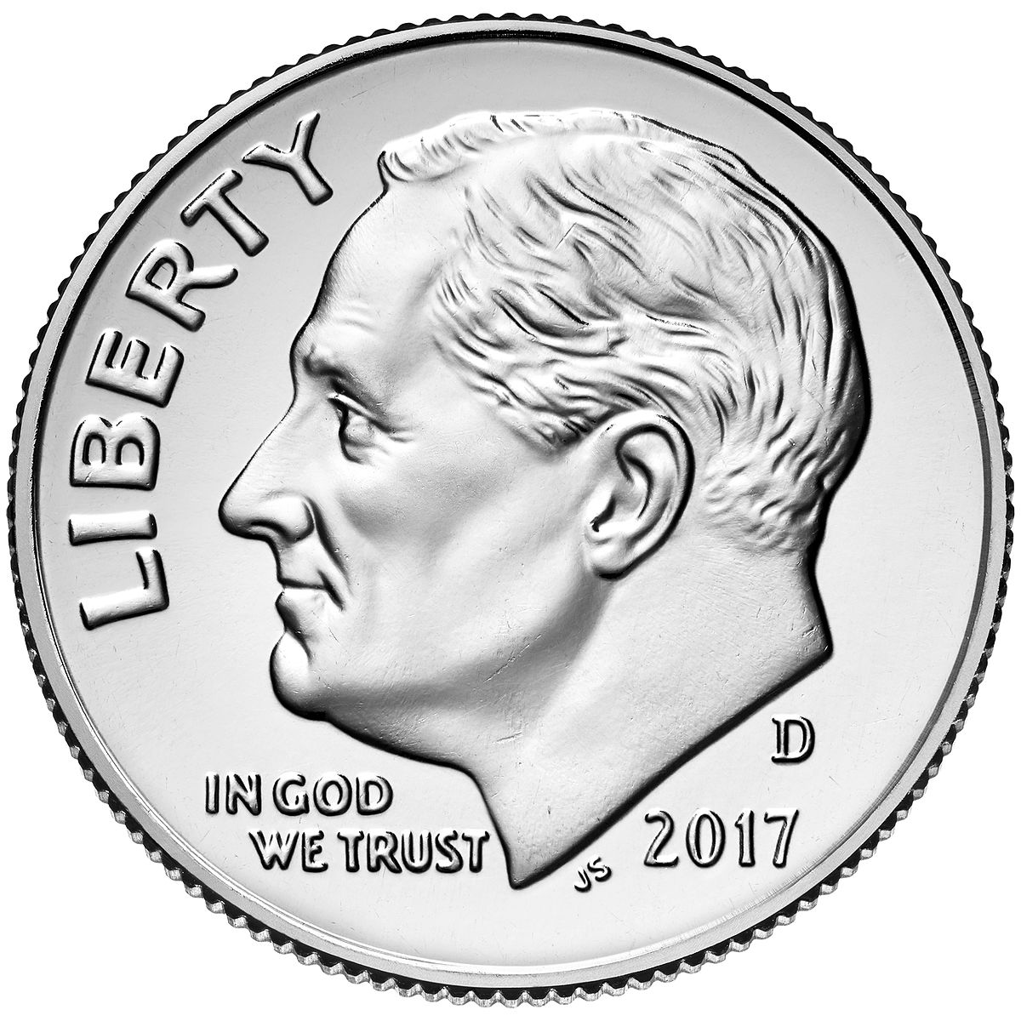
I remember that
you’re worth ten!
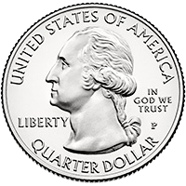
Quarter, quarter big and bold,
25¢
you’re worth
twenty-five I’m told!

