**How to Make Your Wallets**

**Resources**

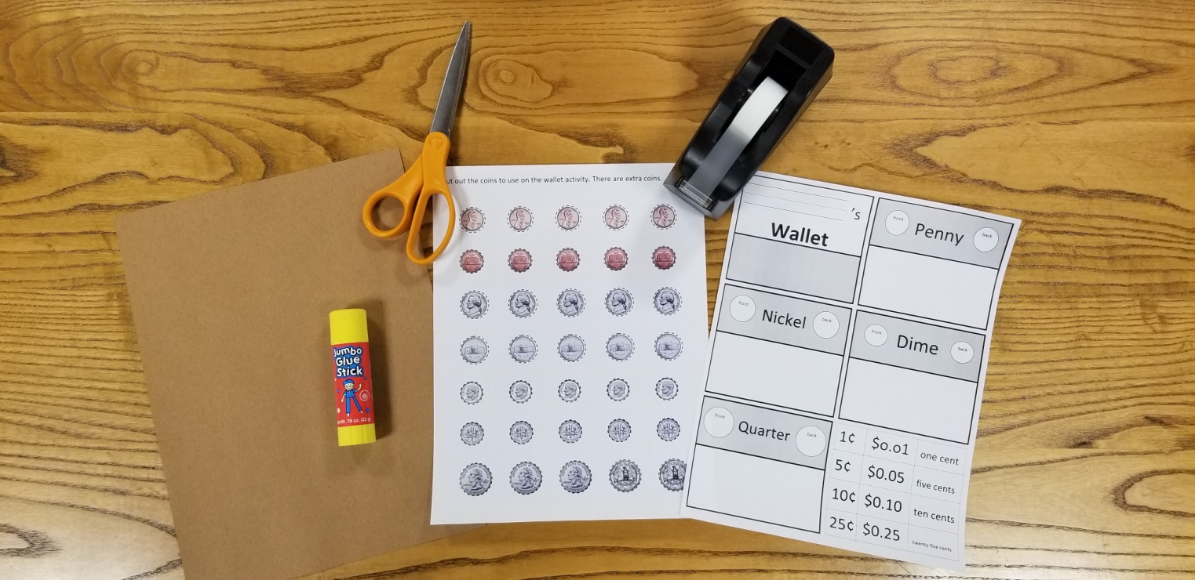

**2. Fold paper into thirds.**

**1. Fold paper hot dog style.**

**Terms and plates**

**Coins**

**Paper**

**Glue**

**Tape**

**Scissors**

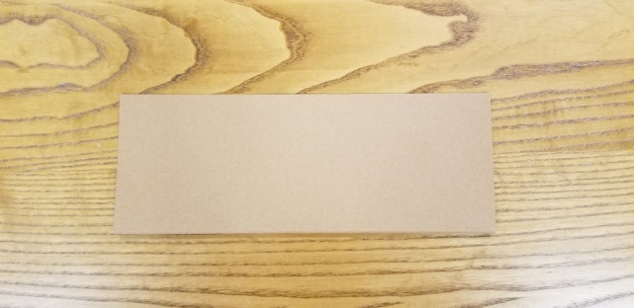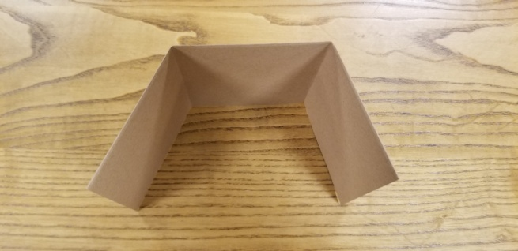

**3. Tape the ends.**

**4. Cut out plates and terms**

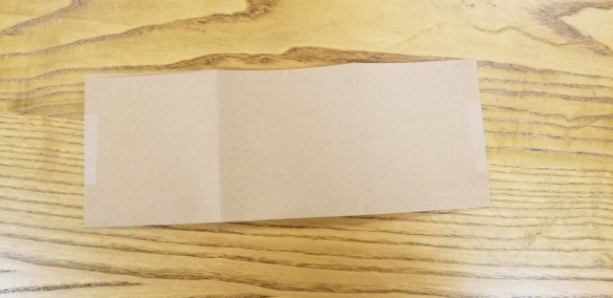 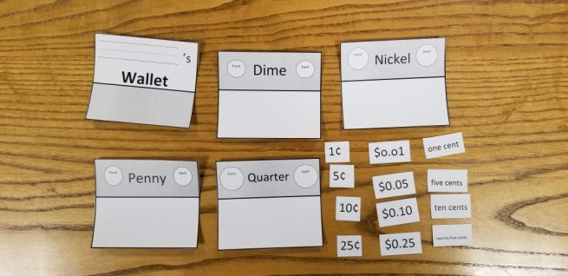

**Inside Folds of wallet**

**6. Glue in Sections**

**5. Glue in nameplate.**

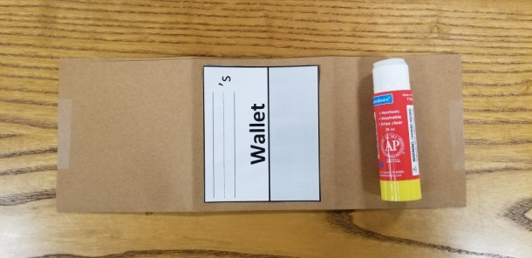 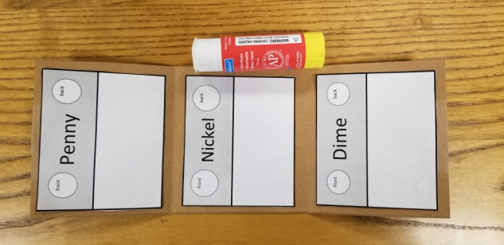

**Outside folds of wallet**

**8. Glue in terms.**

**7. Glue Quarters on this part.**

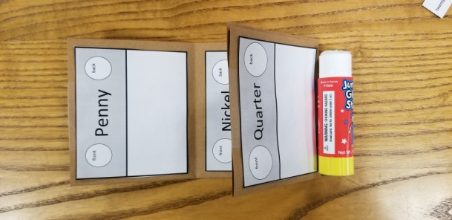 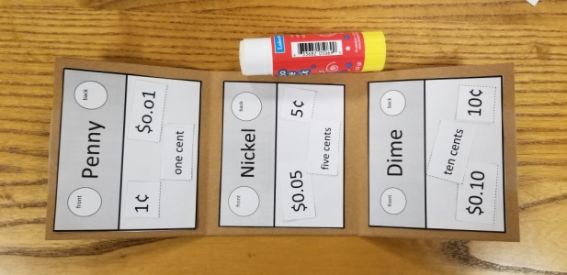

**10. Glue in coins.**

**9. Cut out coins (all or part-8 needed)**

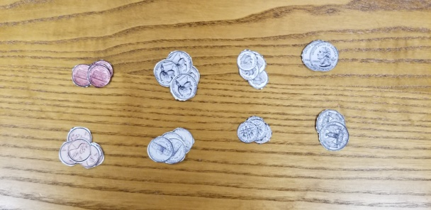 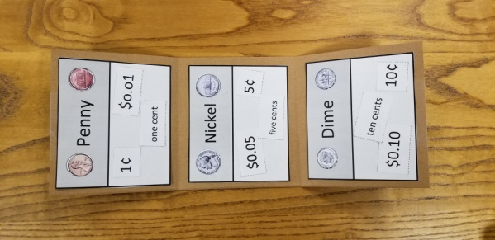

**11. Write your name**

**12. Extra coins in wallet**

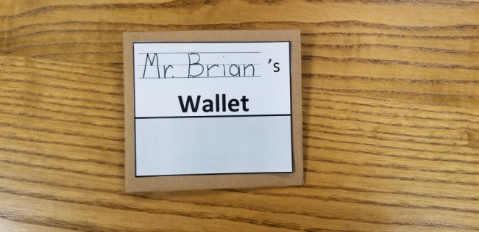 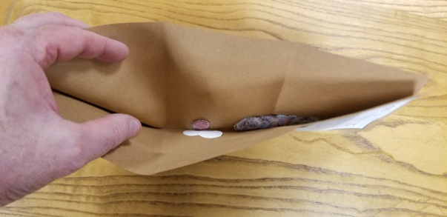

**Finished Wallet**

