200 pages (ages 10-18)  or 7 books (ages 2-9) | 200 pages (ages 10-18)  or 7 books (ages 2-9) | 200 pages (ages 10-18)  or 7 books (ages 2-9)
200 pages (ages 10-18)  or 7 books (ages 2-9) | Lois Wagner Memorial Library | 200 pages (ages 10-18)  or 7 books (ages 2-9)
200 pages (ages 10-18)  or 7 books (ages 2-9) | 200 pages (ages 10-18)  or 7 books (ages 2-9) | 200 pages (ages 10-18)  or 7 books (ages 2-9)
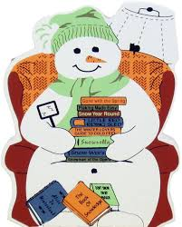
Snuggle Up and Read
Winter Reading Program
Name______________________________
Date___________________________

