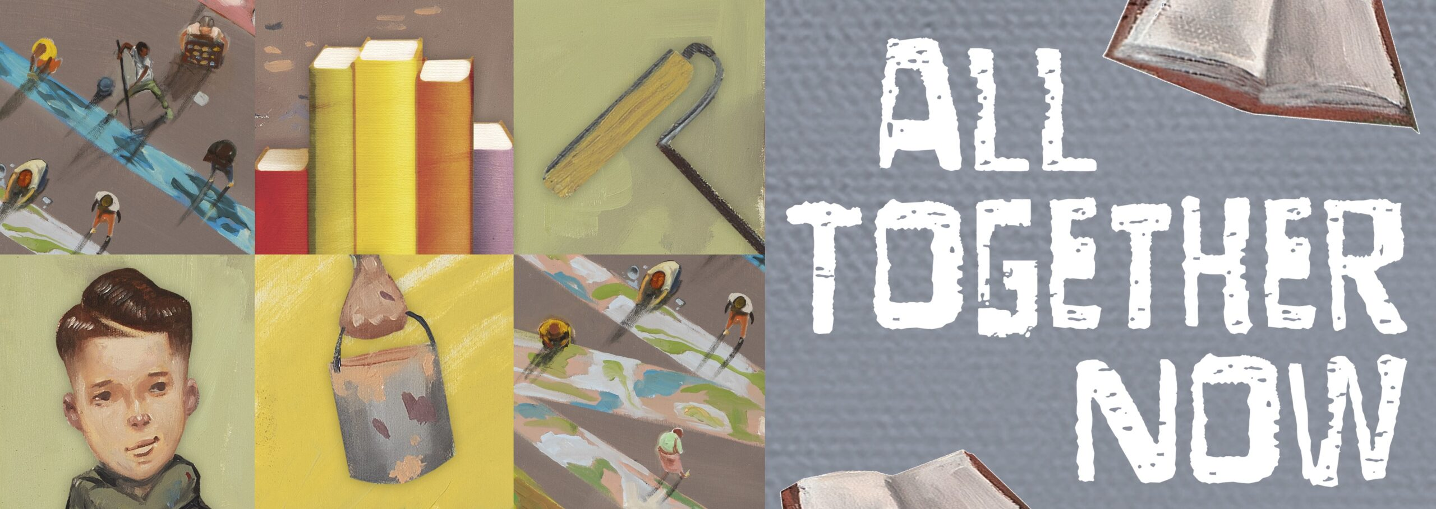
Ends: July 28, 2023
Read a book that has been made into a movie or TV show. | Read a book with a main character that is an artist, musician, or athlete | Read a collection of short stories or essays by different authors. | Read a book about a character that practices a different religion than you. | Read a graphic novel about a superhero.
Read a graphic novel that is NOT about a superhero. | Read a book about a person of color. | Read a book with a character with mental illness. | Read a book that is more than 500 pages. | Read a book that is less than 200 pages.
Read a nonfiction book that has organisms working together. | Read a book written before the year 2000. | Read anything you want. | Read a book you have read before. | Read a book written by a teenager.
Read a book that has time travel. | Read a book recommended by a librarian or library staff. | Read a novel in verse or a poetry collection. | Read a biography or autobiography. | Read a book with an animal on the cover.
Read a book from a genre you haven’t read before…or rarely read. | Read a book from a series | Read a book that has won an award. | Read a book on the list on the back of this page. | Read a nonfiction book about some aspect of nature.

Lois Wagner Memorial Library

2023 YA Summer
Reading Challenge

Complete a BINGO, earn a raffle ticket.
You may complete a BINGO vertically,
horizontally, diagonally, four corners, or
black out…for 14 possible tickets!
7 tickets=Invite to Celebration
Prizes drawn on August 1, 2023.

Name ________________________________________________ age _____________
Sponsored by:
The Friends of the Lois Wagner Memorial Library

