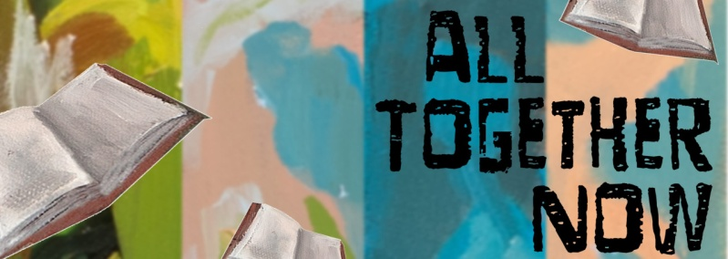
YA Summer Reading Possibilities
- Scythe by Neal Shusterman (Book 1) (YA SCI-FIC SHUSTER)
- Revenge of the Witch (Book 1) by Joseph Delaney (YA FANTASY DELANEY)
- Ruins of Gorlan (Book 1) by John Flanagan (YA FANTASY FLANAGA)
- Lock and Key: The Initiation (Book 1) by Ridley Pearson (YA MYSTERY PEARSON)
- Steelheart (Book 1) by Brandon Sanderson (YA SCI-FIC SANDERS)
- Between Shades of Gray by Ruta Sepetas (YA SEPETAS)
- Enola Holmes and the Black Barouche by Nancy Springer (YA MYSTERY-BOOK 7)
- Dark Rise by C. S. Pacat (YA PACAT-BOOK 1)
- We Deserve Monuments by Jas Hammonds (YA HAMMOND)
- Pony by R. J. Palacio (J PALACIO)
- Four for the Road (YA REILLY)
- All-American Boys by Jason Reynolds (YA REYNOLD)
- Whispering Alaska by Brendan Jones (J JONES)
- Midnight Lie by Marie Rutkoski (YA FANTASY RUTKOSK-BOOK 1)
- Wildoak by C. C. Harrington (J HARRING)
- Northwind by Gary Paulsen (J PAULSEN)
- Thirst by Varsha Bajaj(J BAJAJ)
- Counting by 7s by Holly Goldberg Sloan (YA SLOAN)
- Alcatraz vs. the Evil Librarians by Brandon Sanderson (J SCI FI SANDERS)
- They Called Us Enemy by George Takei (YA GN TAK)
- Hey, Kiddo by Jarrett J. Krosoczka (YA GN KROSOCZKA)
- Science of Being Angry by Nicole Melleby (J MELLEBY)
- Pax by Sara Pennypacker (J PENNYPA-BOOK 1)
- Shout by Laurie Halse Anderson (YA BIO ANDERSON)
- Are You There God, It’s Me Margaret by Judy Blume (J BLUME)
- Fighting Words by Kimberly Brubaker Bradley (J BRADLEY)
- Big Lies by Mark Kurlansky (YA 302.3 KUR)
- Wink by Rob Harrell (J HARRELL)
- War Stories by Gordon Korman (J KORMAN)
- The Superteacher Project by Gordon Korman (J KORMAN)

