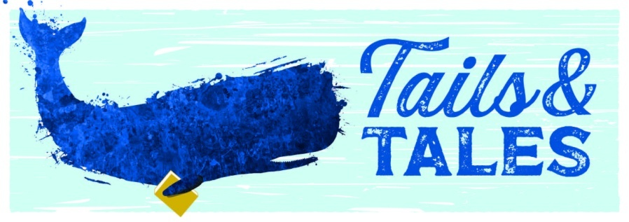
YA Summer Reading Possibilities
- Scythe by Neal Shusterman (Book 1) (YA SHUSTER)
- Revenge of the Witch (Book 1) by Joseph Delaney (YA DELANEY)
- Ruins of Gorlan (Book 1) by John Flanagan (YA FLANAGA)
- Lock and Key: The Initiation (Book 1) by Ridley Pearson (YA PEARSON)
- Steelheart (Book 1) by Brandon Sanderson (YA SANDERS)
- Between Shades of Gray by Ruta Sepetas (YA SEPETAS)
- The Book Thief by Markus Zusak (YA ZUSAK)
- Cemetery Boys by Aiden Thomas (YA THOMAS)
- The Grace Year by Kim Liggett (YA LIGGETT)
- The Left-Handed Booksellers of London by Garth Nix (YA NIX)
- First & Then by Emma Mills (YA MILLS)
- All-American Boys by Jason Reynolds (YA REYNOLD)
- Six Angry Girls by Adrienne Kisner (YA KISNER)
- All the Wind in the World by Samantha Mabry (YA MABRY)
- The Grief Keeper by Alexandra Villasante (YA VILLASANTE)
- Punching the Air by Ibi Zoboi and Yusef Salaam (YA ZOBOI)
- Legendborn by Tracy Deonn (YA DEONN)
- Counting by 7s by Holly Goldberg Sloan (YA SLOAN)
- Alcatraz vs. the Evil Librarians by Brandon Sanderson (J SCI FI SANDERS)
- They Called Us Enemy by George Takei (YA GN TAK)
- Hey, Kiddo by Jarrett J. Krosoczka (YA GN KROSOCZKA)
- March (Book 1) by John Lewis (YA GN LEWIS)
- Shooting the Moon by Frances O’Roark Dowell (YA DOWELL)
- Shout by Laurie Halse Anderson (YA BIO ANDERSON)
- A Wish in the Dark by Christina Soontornvat (J SOONTOR)
- Fighting Words by Kimberly Brubaker Bradley (J BRADLEY)
- Before the Ever After by Jacqeline Woodson (J WOODSON)
- Wink by Rob Harrell (J HARRELL)
- Unplugged by Gordon Korman (J KORMAN)
- Everything Sad is Untrue by Daniel Nayeri (J NAYERI)

